**8-BIT MULTIPLICATION**

**EXP NO:3**

**AIM:** To write an assembly language program to implement 8-bit multiplication using 8085 processor.

**ALGORITHM:**

1. Start the program by loading the first data into the accumulator.
2. Move the data to a register.
3. Get the second data and load it into the accumulator.
4. Multiply the two register content.
5. As the multiplication of two 8-bit numbers can be maximum 16-bita so we need register pair to store the result.
6. Halt

**PROGRAM**:

LDA 8500

MOV B,A

LDA 8501

MOV C,A

CPI 00

JZ LOOP

XRA A

LOOP1: ADD B

DCR C

JZ LOOP

JMP LOOP1

LOOP: STA 8502

RST 1

**INPUT:**

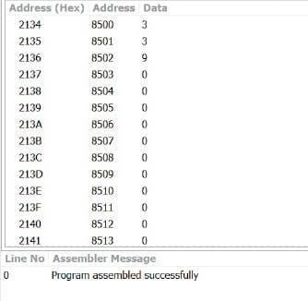

**OUTPUT:**

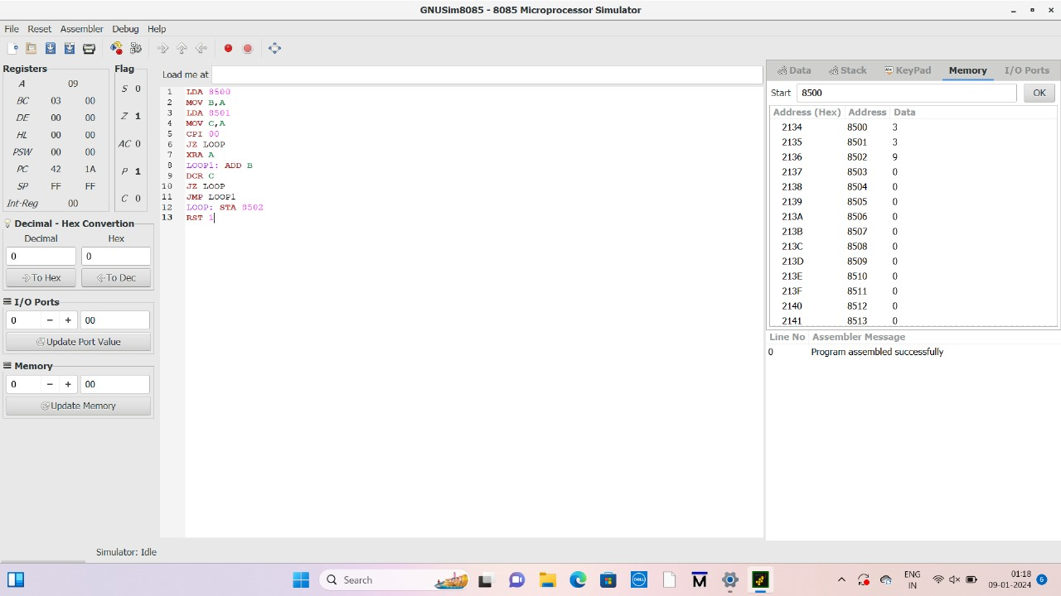

**RESULT:** Thus the program was executed successfully using 8085 processor simulator.